Saturday, March 27, 2021—The Memorial of Christ’s Death
During the Memorial season each year, many Christians meditate on the two greatest expressions of love ever shown​—those of Jehovah God and of his Son, Jesus Christ. (Joh 3:16; 15:13) Using this chart, you can compare the Gospel accounts of Jesus’ final ministry in Jerusalem. These events are discussed in section 6 of the book Jesus​—The Way, the Truth, the Life. How will the love of God and of Christ motivate you?​—2Co 5:14, 15; 1Jo 4:16, 19.

FAMILY WORSHIP SUGGESTION
Watch and discuss the videos ‘For a Certainty God Made Him Lord and Christ’​—Parts I and II.
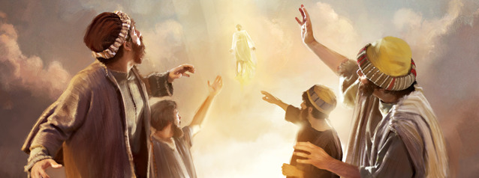

Tuesday, March 23, 2021 Memorial Bible reading: (Daytime events: Nisan 9) Luke 19:29-44

Wednesday, March 24, 2021 Memorial Bible reading: (Daytime events: Nisan 10)

Luke 19:45-48; Matthew 21:18, 19; 21:12, 13

Thursday, March 25, 2021 Memorial Bible reading: (Daytime events: Nisan 11) Luke 20:1-47

Friday, March 26, 2021 Memorial Bible reading: (Daytime events: Nisan 12) Luke 22:1-6; Mark 14:1, 2, 10, 11

Memorial Date After Sundown Saturday, March 27, 2021 Memorial Bible reading: (Daytime events: Nisan 13) Luke 22:7-13; Mark 14:12-16 (Events after sunset: Nisan 14) Luke 22:14-65

Sunday, March 28, 2021 Memorial Bible reading: (Daytime events: Nisan 14) Luke 22:66-71

Monday, March 29, 2021 Memorial Bible reading: (Daytime events: Nisan 15) Matthew 27:62-66

Tuesday, March 30, 2021 Memorial Bible reading: (Daytime events: Nisan 16) Luke 24:1-12

